**WIND ENERGY AND ITS IMPORTANCE**

**MOOC COURSE ON COURSERA**

**FROM**

**DENMARK TECHNICAL UNIVERSITY**

**A Project Report**

**Submitted in partial fulfilment of the requirements for the award of degree of**

**Bachelor Of Technology**

**Submitted to**

**LOVELY PROFESSIONAL UNIVERSITY**

**PHAGWARA, PUNJAB**



**From 10/10/2020 to 31/10/2020**

**Submitted By**

**Name of Student: Shiv Chandra**

**Registration No. : 11904848**

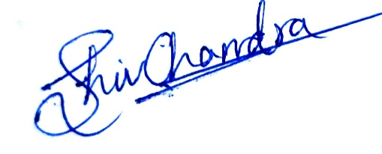

**Signature of the student**

**CONTENTS**

**S. No. Title Page No**

1 Declaration by Student 3

2 Training Certification from organization 4

3 List of Figures/ Charts 5

4 Chapter-1 Introduction to Wind Energy 5-8

5 Chapter-2 Wind Resources 9-15

6 Chapter-3 Economics of Wind Energy 16-22

7 Chapter-4 Wind Energy Technology 22-28

8 Chapter-5 Structural Mechanics 29-32

19 Chapter-6 Material Selection 33-37

10 Chapter-7 Electric System 38-41

11 CONCLUSION AND FUTURE PRESPECTIVE 42-43

12 References 44

**Student Declaration**

**To whom so ever it may concern**

Shiv Chandra, 11904848, hereby declare that the work done by me on “Wind Energy” from 10/10/20 to 31/10/20, is a record of original work for the partial fulfilment of the requirements for the award of the degree, Bachelor of Technology.

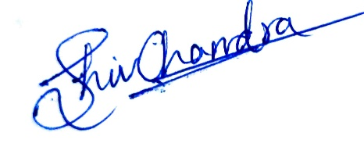

Shiv Chandra

(11904848)

Dated: 5/11/2020

**LIST OF FIGURES/CHARTS**

* Challenges being faced by all countries
* Wind Scanner
* Doppler’s analysis of WT model with Yaw Angle
* Wind Scanner methodologies -3D measuring system
* Wind Lidar
* Site Location
* The wind farm project timeline
* Electricity Mix in India
* Wind investments compared with life time avoided fuel and CO2 costs
* Electricity Production vs Electricity Consumption in INDIA
* Revenue-Support Mechanism (1)
* Revenue-Support Mechanism (2)
* Components of the Cost
* Components of Wind Energy Plant
* Main degrees of freedom
* Different foundations and platforms used
* Wind Turbine Design
* Comparison between BEM and CFD
* Blade Division in Blade Momentum Theory
* Wind Turbine Evolutions
* Schematic for a blade aerodynamic load.
* Growth in Wind Energy capacity from 1995 to 2015
* Life stages of a wind turbine blade: “smart-blade” design methodology
* Surface approximation for a blade rib and lower skin
* Layout of wind power plant
* 3D blade finite element mesh to a 2D quadrilateral element

** CERTIFICATE**

**Chapter-1: INTRODUCTION OF THE WIND ENERGY**

* **Objectives of the Work**

Here are some learning objectives of the course:

* Details on Wind Resources and its importance
* Applicability of Wind Energy.
* Perform simple calculations for assessing wind farm projects and for calculating the cost of energy from wind
* Account for the configuration and energy production of different wind turbine designs
* Details about thrust and power for a wind turbine
* Details on turbine blade based on different material’s properties
* Defining loads on beams, reactions and internal forces
* Applying a strategy for controlling the rotor speed of a variable speed wind turbine.
* Determining the annual energy production for a wind turbine
* Different technologies used in Wind Energy Process.
* Perform simple calculations for assessing wind farm projects and for calculating the cost of energy from wind
* **Importance and Applicability**

“Wind power is the most efficient technology to produce energy in a safe and environmentally sustainable manner: it is zero emissions, local, inexhaustible, competitive and it creates wealth and jobs”

* **Importance**: -

1. The project is environment friendly.
2. India has good wind potential to harness wind energy.
3. A permanent shield against ever increasing power prices. The cost per kwh reduces over a period of time as against rising cost for conventional power projects.
4. The cheapest source of electrical energy. (on a levelled cost over 20 years.)
5. Least equity participation required, as well as low cost debt is easily available to wind energy projects.
6. A project with the fastest payback period.
7. A real fast track power project, with the lowest gestation period; and a modular concept.
8. Operation and Maintenance (O&M) costs are low.
9. No marketing risks, as the product is electrical energy.
10. A project with no investment in manpower.

* **Applicability: -**

1. The wind energy is used to propel the sailboats in river and seas to transport men and materials from one place to another.

2. Wind energy is used to run pumps to draw water from the grounds through wind mills.

3. Wind energy has also been used to run flourmills to grind the grains like wheat and corn into flour.

4. Now-a-days wind energy is being used to generate electricity.

* **Scope of Wind Energy**

The global offshore wind capacity is set to increase fifteen-fold by 2040 to reach about $1 trillion of cumulative investment, according to the recent International Energy Agency (IEA) report. This increase is contributed by falling costs, supportive government policies and rapidly progressing technology, such as larger turbines and floating foundations, according to the Offshore Wind Outlook 2019.

India’s well-developed wind power industry has the capability and experience to help meet the country’s climate and energy security goals. With the total wind installed capacity of around 35,815 MW as of 30th April 2019, India is the world’s fourth largest country in terms of total wind installations after China, the USA and Germany. Wind power has become one of the key renewable energy sources for power generation in India, contributing a share of at least 6-7% to the country’s electricity generation mix at present.

National Institute of Wind Energy (NIWE) has a mandate to carry out wind resource assessments across India. In 2010, it created first ever Indian Wind Atlas in collaboration with Riso, Denmark. At first, it assessed wind potential of 49,130 MW at 50m above ground level. Later, it modified its calculations and estimated that the installable wind potential capacity is around 102,788 MW at 80m above ground level. It also estimated the wind power potential at 100m height as 302,251 MW. These estimations have been arrived given the 2% land availability for all states except for Himalayan states, North-eastern states and Andaman & Nicobar Islands.

Under The IEA New Policies Scenario, India’s wind power market would reach 50 GW by 2020 and 102 GW by 2030. Wind power would then produce close to 105 Terawatt-hour (TWh) every year by 2020 and 294 TWh by 2030, and help save 63 million tons of CO2 in 2020 and 177 million tons in 2030.

The power from green sources such as wind and solar are aimed to fulfil several goals such as energy security, economic development, climate change mitigation, rural development and employment generation. To keep the wind program on track, in 1982, the government established the Department of Non-conventional Energy Sources (DNES), under the Ministry of Energy. In 2006, the ministry was renamed as the Ministry of New and Renewable Energy (MNRE). The government started with the demonstration projects to attract private investment in the sector. From the commencement of the wind program, a market-oriented strategy was implemented. It didn’t involve itself in the direct execution and functioning of wind power projects; rather it worked out the strategy to encourage the involvement of private firms. Over US$ 42 billion investment was made in renewable energy in India during last 4 years.

* **Challenges**

Carbon dioxide in the atmosphere of the earth, and that it's increasing gradually from 390 to 400 parts per million. The CO2 content of the atmosphere is increasing in the wintertime and decreasing in the summertime when we have the photosynthesis active. The increase of global temperature from all the meteorological stations in the world. The global mean temperature is increasing all along those 135 years by 1.4 degrees Celsius.

The need for wind energy in the energy system is to replace fossil fuel based electricity generation. As we have seen, to combat climate change on a global scale, but also to mitigate environmental concerns which is more on a regional or a local scale, which is associated with.

Fossil fuel-fired power plants emission of particles, nitrogen oxides, or sulphur oxides. Wind

energy is also increasing the security of energy supply of our energy system because it is a

domestic fuel that we don't need to import from politically unstable regions of the globe. It is

cost competitive It would be traditional power generation and it provides local employment   and regional economic development.

It can be installed very fast compared to conventional power plants.

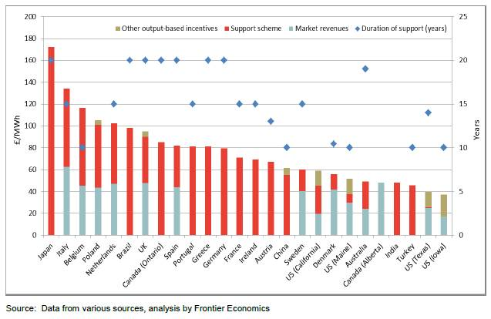

Figure 1.1 Challenges being faced by all countries

**Chapter-2: WIND RESOURCES**

* **Wind Profiles**

There is a difference between the wind profile during the night and during the day. The simplest form for the wind profile is a so-called logarithmic wind profile.

U (z) = U (ln Z / Zo - £ ) / k , the wind profile, the wind as a function of height, where Z is height is described as function of the U star, which is the momentum flux, it's a function of height Z and it's a function of the surface roughness, and it's a function of the stability function. In neutral conditions, the stability function is zero. The Psi there is the stability function, and therefore, we have a purely logarithmic profile in neutral condition. Neutral condition means that there is no heat flux from the surface, so it corresponds to overcast conditions with high wind speeds. The geostrophic wind is a wind that drives the wind near the surface. It's the wind speed at about 1 kilometre’s height. It's characteristic that the wind varies a lot near the surface during the day and at night. During the night it's difficult for the energy to come to the ground because of the reduced momentum flux and the wind speed reduces near the ground. Although the wind speed is low near the ground, it increases fairly fast with height. And at a height of about 100 meters it can sometimes even be faster than the neutral wind speed. During the day there is a better of connection to the geostrophic wind. You have a higher wind speed during the day then during the night.

* **Wind Energy Concepts**
* **Navier-Stokes Equation**

It is an evolution equation which tells about how the wind speed evolves with time as well as in space.

* **Turbulence Spectra**

A very important statistical concept. It tells us about the distribution of the kinetic energy of wind with respect to the frequency.

* **Wind Vector**

It has a magnitude and a length, a magnitude and a direction, so the direction is measured with respect to a certain reference axis which is called as Wind Direction.

* **Turbulence intensity**

This is a statistic, which is used to quantify turbulence, and what information is required to estimate sample turbulence intensity is the mean wind speed and the standard deviation.

* **Standard Deviation**

It is simply computed using the fluctuations of the time series.

* **Integral Scales**

It is that if we take a look at the time series, and if we simply take a wind speed at 200 seconds.

* **Sampling Frequencies**

It also depends on the integral time scale. So normally, the sampling frequency should be much smaller than the Integral Time Scale. Otherwise the random errors in the estimated turbulence statistics are quite large.

* **Wind Scanner – remote sensing of wind**

Meanwhile, in the beginning of the Millennium, wind turbines reached 100 - 120 meters. And today we have huge turbines for the wind industry, and they are more than 220 meters tall. So we are reaching almost the size of the Eiffel Tower with these turbines that are running in the atmosphere and therefore, we need to measure the wind at very high heights and at very big fields. So the good old technique , a meteorological mast is very difficult to apply today because a meteorological mast only measures a wind field at one point where it's sitting, and at a single vertical profile, but we need to measure the wind field over the entire rotor plane of the big turbines.

The challenge of using remote sensing instead of an in-situ instrument is that you need to

measure the wind by not being there. If you had set up a cup anemometer that rotates, then you

count how many revolutions at that point in time, but with remote sensing, you can only

transmit. You need to look at the signal that you get back either from sound propagation

or from light propagation. You can also look at the sky, look at the clouds and see how fast

they move. This is passive. But to measure the wind field around the big turbines in an active

way, we have developed a system now that relies on remote sensing, active remote sensing. So

we transmit a laser beam sound beam, then we detect the Doppler shift that we receive back

from this.

* **Challenges with Remote sensing**

1. You need to have a sizable signal back that you can detect. That's something with signal to noise and we need to have a decent signal to noise ratio in our measurements.
2. Remote sensing techniques are diffused in the sense that they don't measure just in one point, but they measure in a volume or in an area.

* **Block Diagram of Wind Scanner**

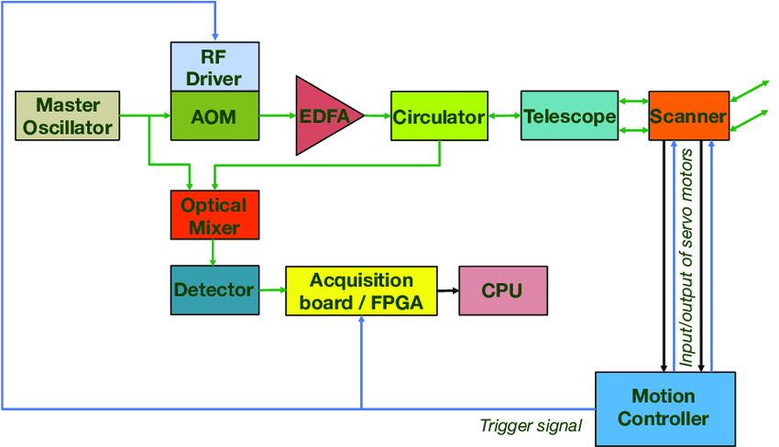

Figure 2.1 Wind Scanner

* **Doppler Effect**

Due to the moving blades of the wind turbine, the frequency of the signal will be shifted according to the Doppler Effect. The Doppler frequency shift depends on the radial velocity of the moving object with respect to the receiver. As a consequence, a frequency spread will be caused in the signal spectrum, which will depend not only on the rotation angular speed of the blades, but also on the blade length and on the relative orientation of the nacelle with respect to the transmitter and the receiver.

 a wind turbine may cause a scattered signal of dynamic nature which is both amplitude and frequency modulated due to the rotating blades. The time and frequency characteristics of this scattering signal will depend on multiple factors. Some of them are fixed, such as the distance from the transmitter and the dimensions and materials of the wind turbine, while other are time-varying, such as the nacelle orientation and the rotation speed of the blades.

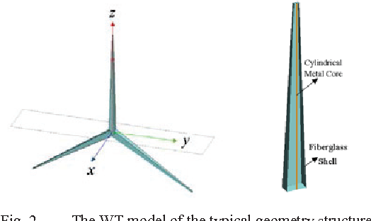

Figure 2.2 Doppler’s analysis of WT model with Yaw Angle

The investigation into the effect of the wind turbines (WTs) on the radar system is increasing with the growing demands for wind farms. In order to evaluate the Doppler spectrum features of the rotational WT, a simplified WT model with high reliability is proposed and the simulation results are conducted in this paper. Then the Doppler effect under different characteristics are also analyzed by utilizing quasi-stationary method as well as the Fast Fourier Transform (FFT).

The Doppler effect, named after Christian Doppler, is the change in frequency and wavelength of a wave as perceived by an observer moving relative to the source of the waves. For waves that propagate in a wave medium, such as sound waves, the velocity of the observer and of the source are calculated relative to the medium in which the waves are transmitted. The total Doppler effect may therefore result from either motion of the source or motion of the observer.

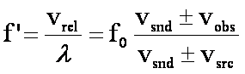

Where vrel is the relative speed between the pulse and the observer and vsnd is the speed of sound. Wind has essentially the same effect as an increase or decrease in sound velocity. If the crests are moving with the wind (in the same direction as the wind), then sound velocity is effectively increased. We have the dispersion relation for the Doppler shift which is a relation between the frequency and the wave number that's given and we transmit a frequency f_0 which is very stable. The very stable frequency hits an aerosol and the aerosol acts like a small mirror and transmit light back. So because the aerosol acts like a mirror, it is an elastic scatter we are talking about, so the back scattered wave number is almost the same as the incoming wave number. So you can tell that from this if it's an elastic scatter, the change in wave number is simply twice the lengths or the size of the wave number. And to calculate the change in the wave number, it's vector sum, so you can take the return signal minus the incoming wave number, and that's a minus 2 times the size of the vector itself. So from here the minus 2 comes that I showed you in the previous equation. Now you take the delta k and put it into the dispersion relation, and then you have the Doppler shift equation. And the Doppler shift equation simply says that if you have a wavelength, a laser or sound with a certain wave number, and you have a speed of the object that you are measuring, then you get a frequency shift of this order it is minus two times the Doppler shift velocity divided by the wavelengths. And if you take a laser, it's approximately 1.3 megahertz per meter per second. So if you have a one meter per second wind speed in our laser beam, then we will expect a frequency shift of 1.3 Megahertz, which is easily detectable by today's electronics. So that's the background behind the Doppler shift that we use.

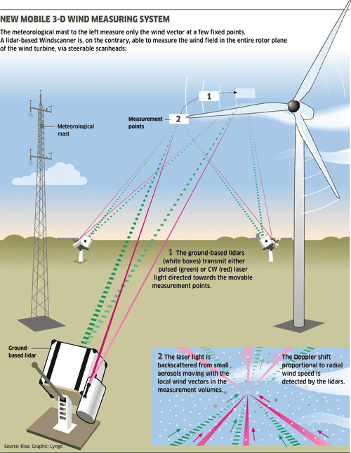

Figure 2.3 Wind Scanner methodologies -3D measuring system

* **Wind**  **Lidar**

Lidar only measures the velocity component in the direction of the laser beam, it doesn't measure the two transverse components. So, if you really want to measure 3D turbulence, you need three of them to be working at the same time and we have developed some instruments that does this. This is a so called Spinner Lidar, it's an instrument that you can install on a turbine, you can put it in to the spinner itself and then it measures the wind speed in front of the turbine and you can use this for controlling the turbine or optimizing the power. It's called a Spinner Lidar. It's still a lidar like we talked about, but here you see this scan head where there are two prisms that can steer the beam in two independent directions.

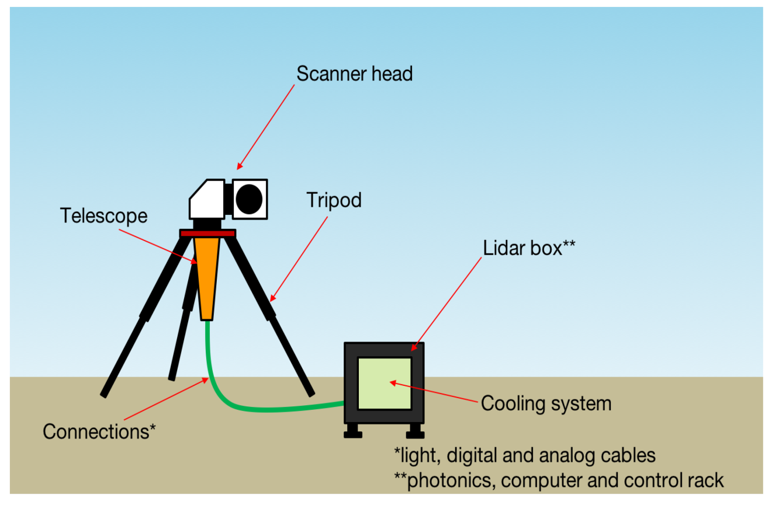

Figure 2.4 Wind Lidar

The laser beam is following this "nice" (rosette) pattern here and every time the colour changes, it has made one measurement. So in this "rosette" scan, which we can run through with the scanner in one second, you get 400 measurements. So what is 400 measurements per second and if you combine that colour code with the wind speed that you measure, you get these high - resolution pictures of the inflow in front of the turbine and this we can refer to as a "wind speed camera". It's a camera that measures the wind speed in front of the turbine and then you can see there can be shear; there can be wakes from other turbines. This is very useful for optimal control of a wind turbine, and also for yawing the turbine into the wind.

* **Wind Data Analysis**

Wind data is obtained from the measurements of a sonic anemometer mounted on a 116.5 m116.5*m* tall meteorological mast, located at Danish National Test Centre for Large Wind Turbines at Høvsøre, Denmark. shows the location of the test center (see inset).The site is about 1.7 km1.7*km* from the North Sea with a mean height of 2 m2*m* above mean sea level and flat homogeneous terrain. The site also comprises five turbine stands, five power curve masts, two lighting towers and a central service building.

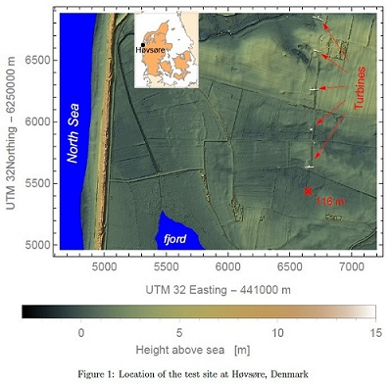

Figure 2.5 Site Location

**Chapter-3: ECONOMICS OF WIND ENERGY**

There are typically four phases of a wind energy farm timeline of the wind farm.

**3.1 Wind Energy Farm Timeline and Process**

The four phases of the wind energy farm timeline are:-

* The development phase
* An implementation phase
* An operation phase
* A decommissioning phase.

So these are the phases involved the making of the wind energy farm. These phases are explained below:-

1. **The Development Phase: -** You need to take a close look at the characteristics of the site to make sure that it is suitable for your project. Not least of course, the wind results. You’ll need to be doing a little bit of the wind farm design; this is a bit of a back and forth iterative process until you get to the final design. You will also need to obtain the correct permits and licenses, and this can take quite some time.

Interesting thing is that this phase here can take five maybe up to ten years and you're using your own money, and you're really not sure, until you get the final permission, as to whether the wind farm is going to go ahead or not.

1. **The Implementation Phase: -** This is the process where we need to buy the equipment and we need to actually construct the wind farm. You can imagine, this is where most of the capital of the whole project is used. This is the capital intensive part. It's relatively short, when well-planned; the construction of a wind farm can go very quickly. The implementation is where we actually construct the wind farm and we need to buy and put in the turbines, we need to make the foundations, substations, and cabling, and at last, of course, we need to actually make the grid connection in order to be able to sell our electricity on into the grid.
2. **The Operational Phase: -** This is the longest phase of your wind farm project. These days, we're designing wind farms for between 20 and 25 years. The daily operation of the wind farm is that, you need to make sure that it is operating as intended, and in order to be able to do that there needs to be regular maintenance of both the wind turbines themselves and all the other ancillary equipment that there is in the wind farm too. And here, we actually have a connection with the final phase, which is the decommissioning phase, because the point at which we decommission will actually very much depend on how well the turbines have been maintained throughout their operational life and when we come to it, we actually have two choices. We can either remove the whole lot of the wind turbines and the foundations and the substation or return the ground to its original use.

Or what is more common these days is to actually repower. This means you still take the old turbines down, but you replace them with much newer and more efficient turbines.

1. **The Decommissioning Phase: -** Finally the last phase is the decommissioning phase and this is really where you either decide you're going to repower, in which case you come to a new project or you take everything away and you return the site to its original purpose. The importance of collaborating across the decommissioning industry for encouraging effective reuse and recycling markets was made clear. Now there has also been developed a design competition that considers ways to reuse steel from decommissioned oil and gas assets. This could be hugely beneficial to design and installation plans for future wind turbines.

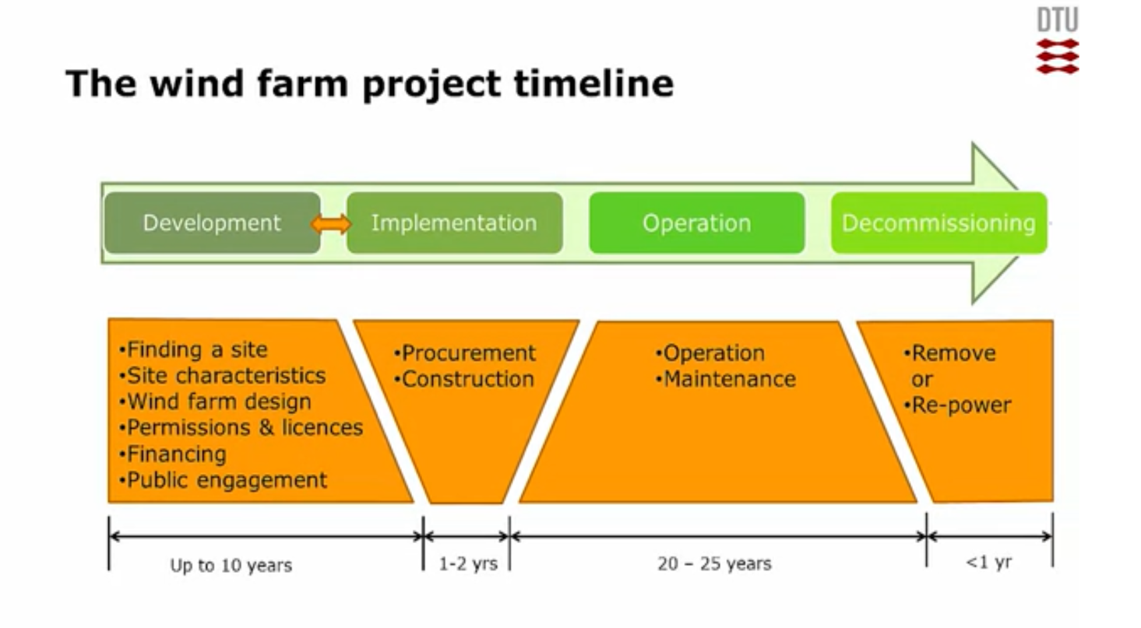

Figure 3.1.1. The wind farm project timeline

After all these we can make a rough estimation of the cost or the capital involved in the setting up the wind energy farm. Therefore, there is a quote which has been given the Danish Energy Agency which says that: "Wind turbines are expensive generating installation investments."

The all sorts of money required is nowadays not alone implied by that particular company so they borrow money from the market.

**3.2 Capital & Revenue in Wind Energy Farm**

**Capital involved in Wind Energy Farm**

For the operation, of a 2 Megawatt machine, which is a very common size these days, we're looking at about 40,000 Euro per machine, per year. 1 Euro= 87.70 in Indian Currency, therefore, it will cost=40,000*87.70= 35, 08,000 Rs. This scene has been taken into account if we install in any foreign country.

But if we talk about India here the scenario is different. Here you do need Rs 30-35 lakhs as capital investment to debut in the most talked-about virgin investment avenue. According to  Indian Wind Turbine Manufacturers Association, says to install the least capacity wind generator of 250 kilowatts (the minimum capacity that can be installed), an individual will have to invest close to Rs 1 crore.

Cost of operation, maintenance and insurance works out to Rs 40,000-50,000 a year. Wind turbine manufacturers give a one-year warranty on an installed turbine.

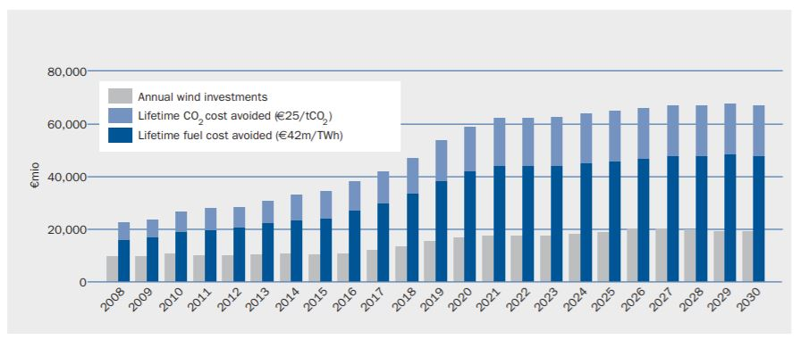

Figure 3.2.1. Wind investments compared with life time avoided fuel and CO2 costs

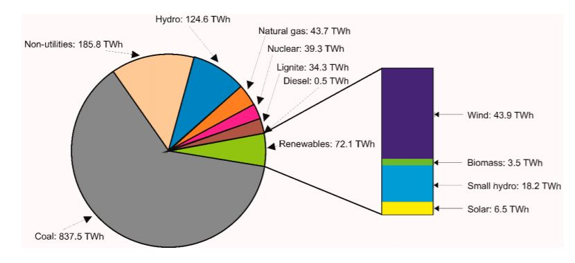

Figure 3.2.2.Electricity Mix in India

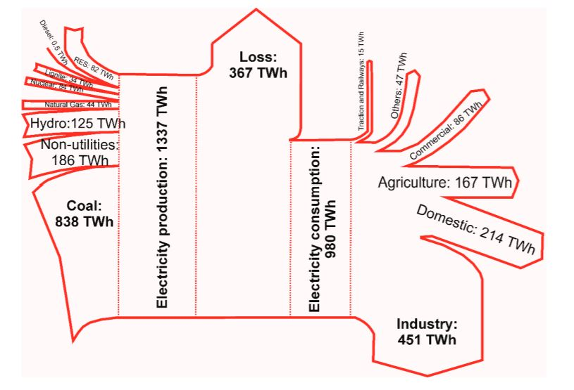

Figure 3.2.2.Electricity Production vs Electricity Consumption in INDIA

**Revenue generated by Wind Energy Farm**

The economic revenue of a wind farm is, of course, related to how much energy it produces. So that means how much energy actually goes through the meter and into the public grid.

So we have these two components, the energy in Megawatt hours, and the price in Rupees per Megawatt hours. We can't use anything information-like from the wind turbines themselves, because we have the losses that go through the cables, and through the transformers, and the switch gear. Before we actually get to the public grid. So we need to take it as a net one at the meter.

Taking an example-

 Let's just say energy generated is 50 Megawatts and we're going to use a capacity factor of 25%, and this means that, on average, the wind farm will be producing at full capacity for 25% of the time. Taking this as a very average figure and if we use these then this will give approximately 110 Gigawatt hours of electricity generated in a year.

So how did we get 110 GW energy? The breakdown is as follows-

Capacity of wind energy farm=50 Megawatts

No. of hours in a year=365*24=8760 Hours

Therefore, total energy produced=50*8760*25% (capacity factor)

=50*8760*0.25

=109500 Megawatts

=110 Gigawatts of energy

Now electrical energy from wind turbines is a commodity, just like any other commodity, it can be bought and sold and the price of this commodity can vary from right down from how much it actually costs to produce up to anything that somebody is prepared to pay for it on the open market.

To support the investment four tariff plans are provided by the government.

1. The Feed-in Tariff- It's very simple, it's been used a lot and what it means is that we get a guaranteed support for each Kilowatt hour or Megawatt hour of electricity that we put into the grid.
2. The Price Premium Tariff- Here we can see that we sell into the market and we get a varying price per Kilowatt hour for our electricity. But to help along, we get a guaranteed fixed support on top of that.
3. Tendering- In this process means an individual developer will bid for a specific project and they will bid saying that we need a certain number of rupees per Megawatt for this project, in order to be able to make it feasible for our business case. Then an authority will take a look at the various bids they've received and make a choice, depending on certain criteria. It could well be that it was just on price.
4. The Green Certificate Scheme- This is a more complex process; here we sell the electricity into the market as usual. But for each Megawatt hour of electricity that we produced, we get green certificates .On the other hand, users of electricity are obliged to buy a certain percentage of their electricity from renewable sources. If they don't, then they can buy these green certificates as some kind of makeup and in this way we have a market of buying and selling these green certificates.

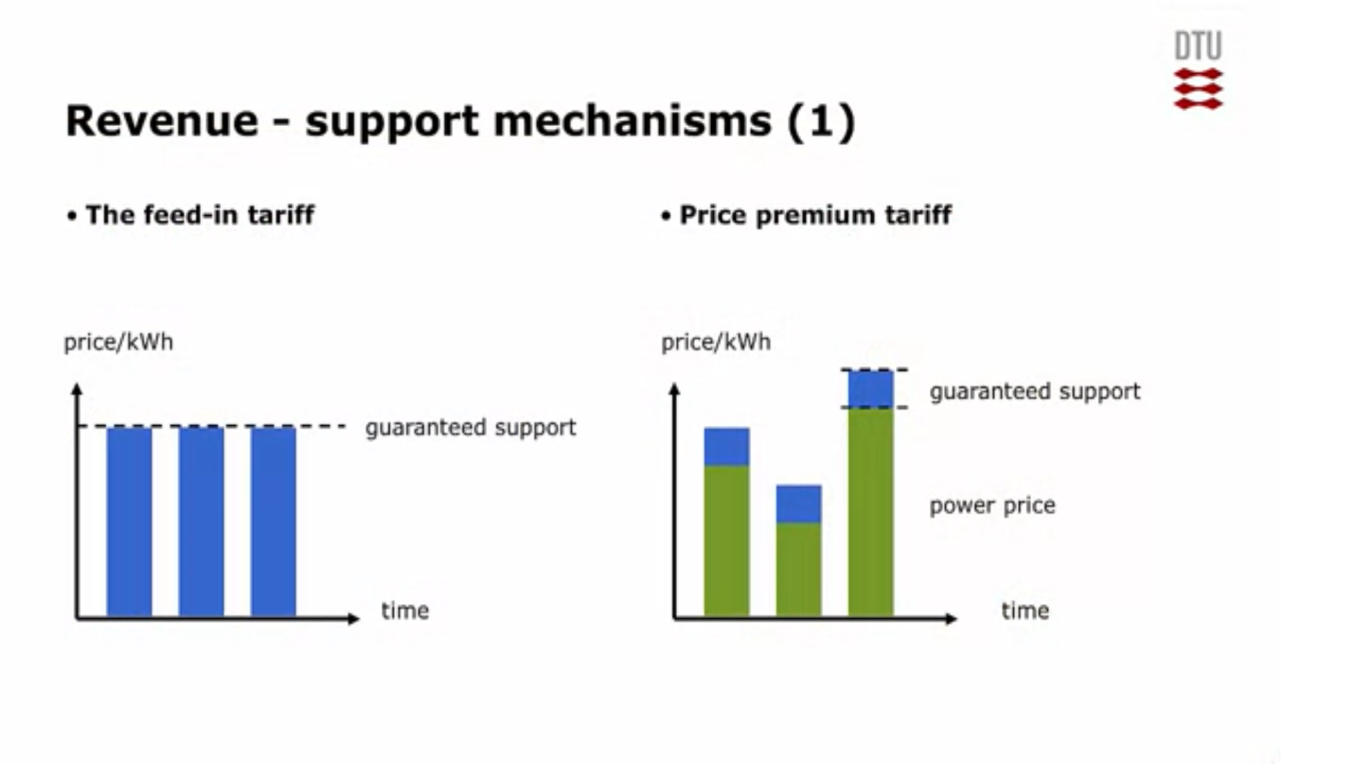

Figure 3.2.3. Revenue-Support Mechanism (1)

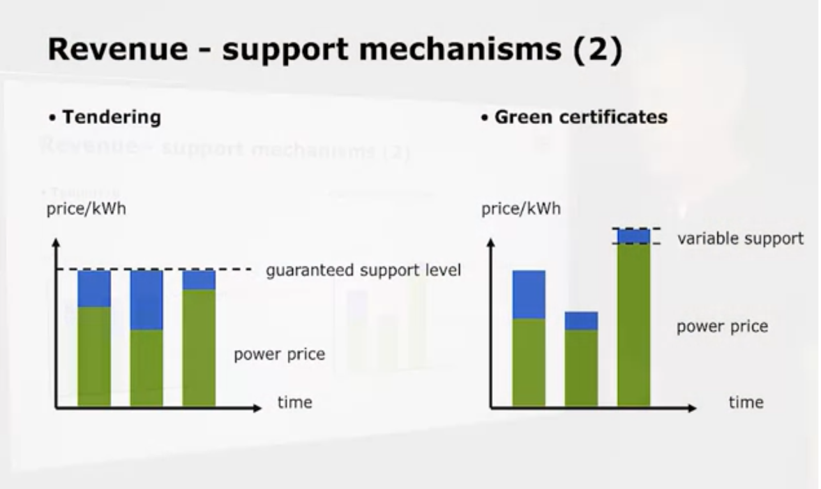

Figure 3.2.4. Revenue-Support Mechanism (2)

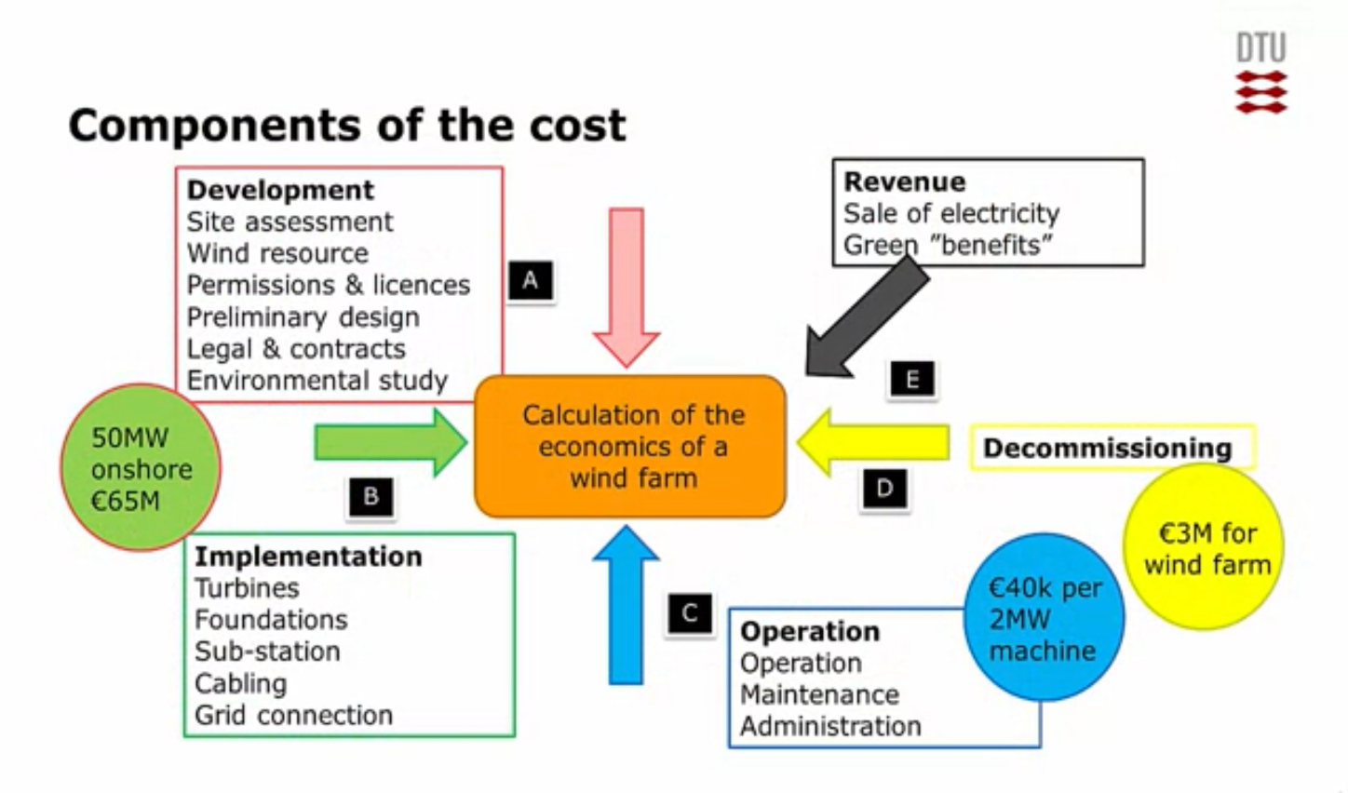

Figure 3.2.5. Components of the Cost

This above image of Components of the cost has been taken into account by the Denmark Technical University which shows the total cost and revenue generated by a Wind Energy Farm.

The electricity generated is finally sold at about 5 to 10 euro cents per kilowatt which is equal to Rs8.77 per kilowatt.

**Chapter-4: WIND ENERGY TECHNOLOGY**

**The wind energy technology uses four principle categories:-**

* Rotating Lift-Based Machines
* Rotating Drag-Based Machines
* Flying Lift-Based Machines
* Machines using Flow Induced Vibration

1. Rotating Lift-Based Machines- The most well known is the horizontal axis wind turbine, where the energy from the wind is extracted from a rotating shaft that is parallel to the wind. It is rotating due to the lift forces on the air foils of its blades. Another concept, the blades are rotating in a horizontal plane, and also driven by lift, where the shaft is now vertical. Therefore, it's called vertical axis wind turbine.
2. Rotating Drag-Based Machines- Here the typical vertical axis turbine is the drag base Savonius turbines where the drag on one side is larger than the drag on the other side. Therefore, creates a moment that makes the shaft rotate.
3. Flying Lift-Based Machines- It is same like that kite pulls a cable and then pulls the generator that is mounted on the ground. It is like extracting the energy from the kite by mounting a propeller, or you could say the horizontal axis turbines on the kite itself, and then fly it in circles and extract the energy from the generators on the kite and then you can transmit the electricity generated through the cable to the ground.
4. Induced Vibrations-In this concept the electricity is generated in the following manner. For example, by making a beam vibrates and has piezo ceramic material that extracts the energy. If we look at the motion itself, of the tip of the airfoil, we see that it is vibrating due to the cross-flow over it.

The main components of a horizontal-axis wind turbine is the rotor blade, the nacelle, and the tower, and it's foundation. And inside the nacelle we have the drive train with the main bearing, the gearbox, the brake and the generator, and some power electronics that converts the power produced in the generator to the grid side through some transformers. The main degrees of freedom is the azimuth rotation of the rotor, which is the one generating the power. The yaw rotation of the nacelle which makes sure that we can turn the turbine into the wind. And then we have the pitch rotation of the blades, about the length with axis which we use for controlling the aerodynamic torque on the rotor.

**Components used in the Wind Energy Technology are-**

1. Rotor- It generates aerodynamic torque from the wind.
2. Nacelle- It converts the torque into electrical power.
3. Tower-It holds nacelle and rotor blades up in the wind and provides access to the nacelle.
4. Foundation- It ensures that the turbine stays upright.

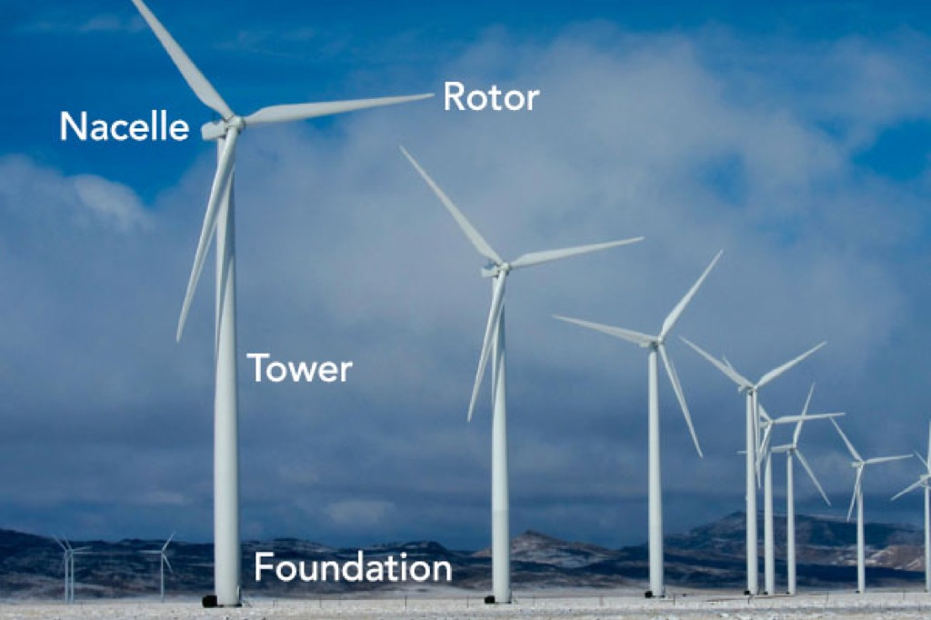

Figure.3.2.6. Components of Wind Energy Plant

**Main degrees of freedom in Wind Turbine and its blade-**

1. Azimuth- Rotation of the rotor about its shaft due to the torque.
2. Yaw- Rotation of nacelle about the vertical lengthwise axis of the tower.
3. Pitch- Rotation of blades about their length wise axis due to pitch control action.

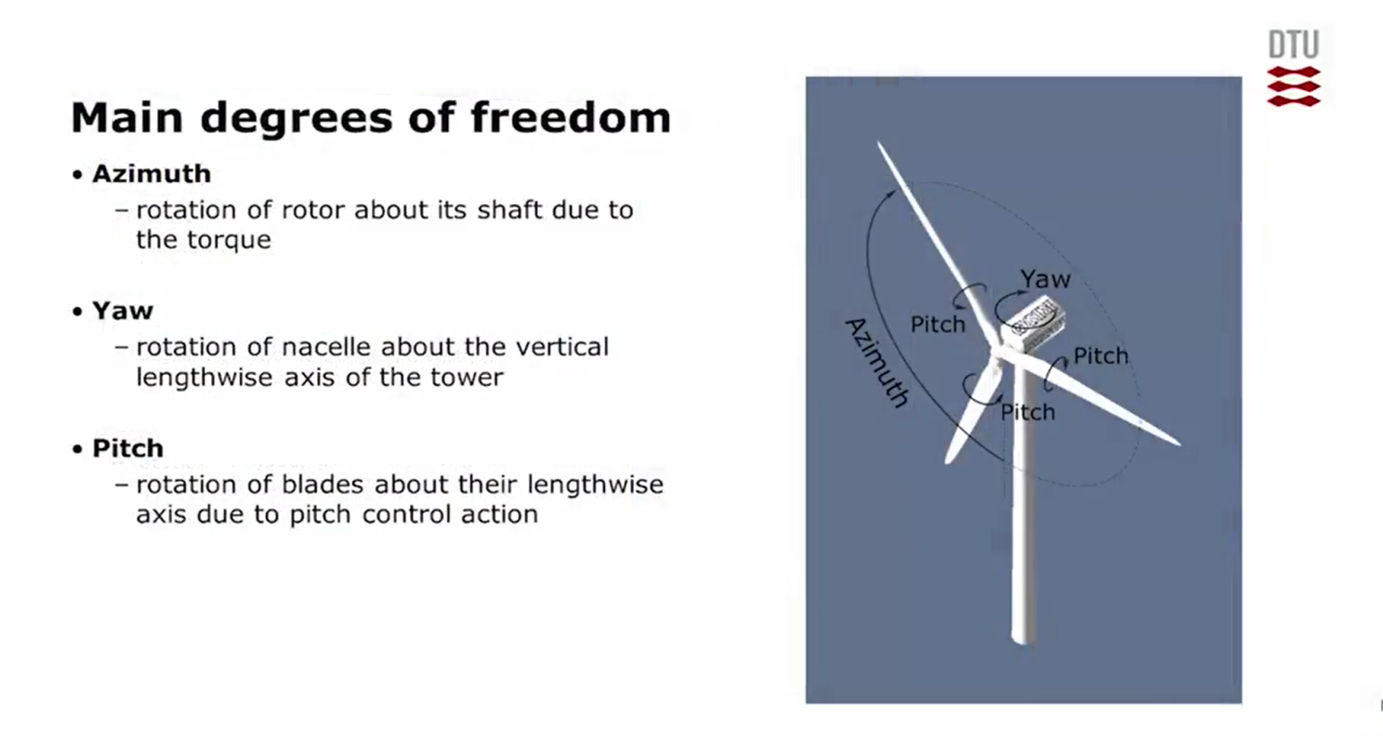

Figure 4.1. Main degrees of freedom

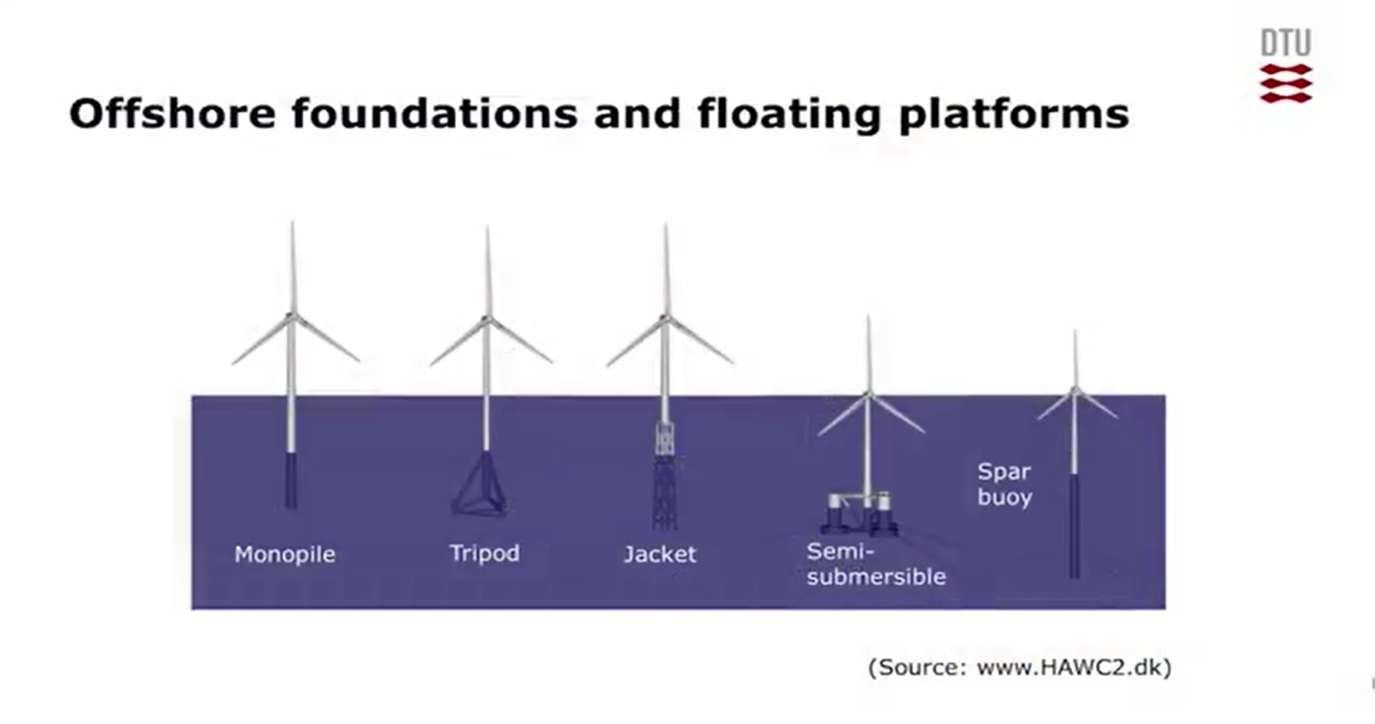

Figure 4.2. Different foundations and platforms used

**Aerodynamics used in Wind Energy technology**

The primary application of wind turbines is to generate energy using the wind. Hence, the aerodynamics is a very important aspect of wind turbines. Like most machines, there are many different types of wind turbines, all of them based on different energy extraction concepts.

The method used to extract power has a strong influence on this. In general, all turbines may be grouped as being either [lift](https://en.wikipedia.org/wiki/Lift_(force))-based, or [drag](https://en.wikipedia.org/wiki/Drag_(physics))-based; the former being more efficient. The difference between these groups is the aerodynamic force that is used to extract the energy.

The governing equation for power extraction is:

P=FV

Where *P* is the power, *F* is the force vector, and *v* is the velocity of the moving wind turbine part.The force *F* is generated by the wind's interaction with the blade. The magnitude and distribution of this force is the primary focus of wind-turbine aerodynamics. The most familiar type of aerodynamic force is drag. The direction of the drag force is parallel to the relative wind. Typically, the wind turbine parts are moving, altering the flow around the part.

From many sources it has using many calculations which has used the concepts of momentum, fluid mechanics, Bernoulli Equation and mass conservation etc have stated that an optimal rotor speed can extract 59% of the incoming kinetic energy and this is the best performance of any wind turbine that can be used.

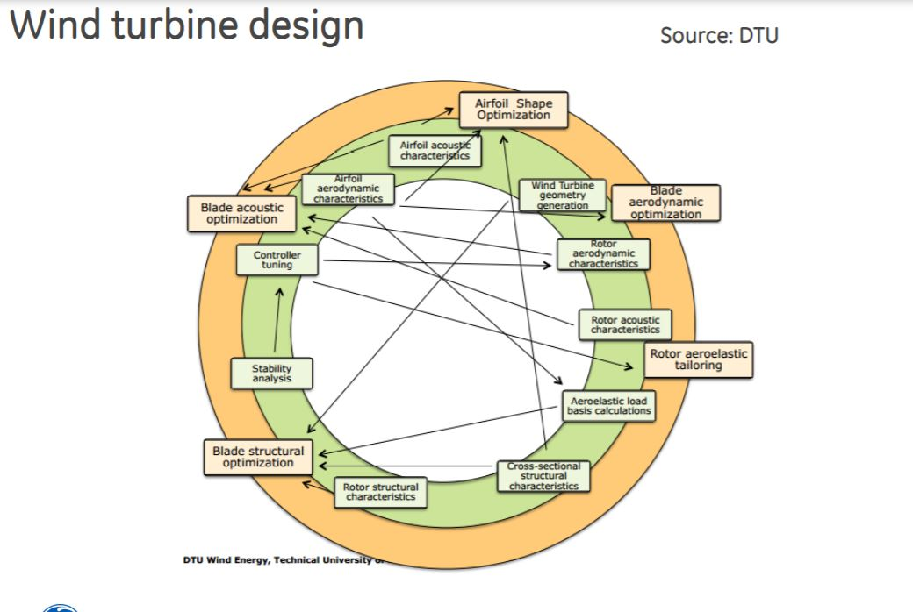

Figure 4.3 Wind Turbine Design

The aerodynamics also tells that:-

* The wind turbine structure must be stiff enough to stand for the flow around. For this reason , the first step in the structure design process is to determine the aerodynamic loads applied to a wind turbine blade.
* There are mainly two methods for predicting a wind turbine aerodynamic load: blade element momentum ( BEM) and computational fluid dynamics ( CFD).
* The BEM can be classified as an analytical method that is fast and accurate.
* The CFD analysis is a numerical method which is based on numerical and empirical approximations.
* In general, the BEM is preferred for initial design and load estimation, while the CFD simulation is preferred for detailed design. Designers usually start using BEM in preliminary design and end up using the CFD simulation for detailed analysis and design
* Blade momentum theory is also taken into account it follows a process which is it he blade is divided into N radial segments; each segment experiences different chord (C), twist angle ( β ), and tangential speed ( Ω r )

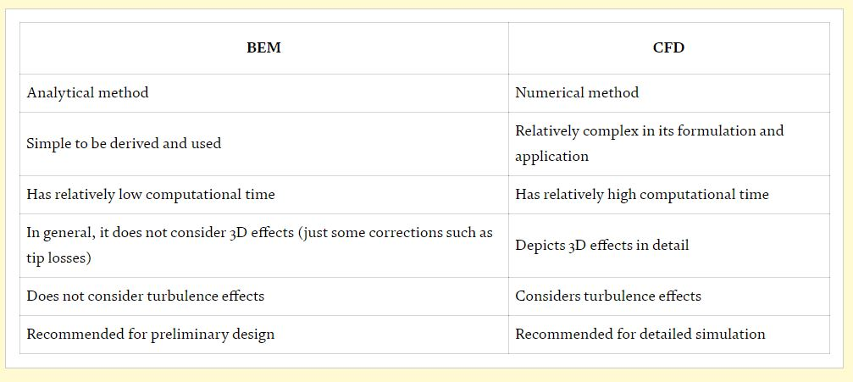

Figure 4.4 Comparison between BEM and CFD

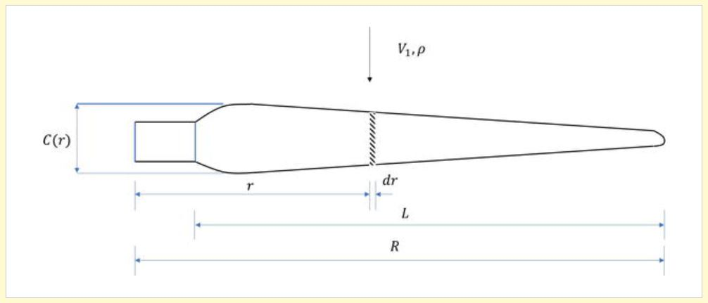

Figure 4.5 Blade Division in Blade Momentum Theory

In schematic description for a blade aerodynamic pressure It can be seen that the maximum force occurs at the blade root and the minimum at the tip. For this reason, wind turbine blades are usually designed with taper in which the airfoil thickness increases toward the blade root. This property makes the blade structure stiffer at the root and lighter at the tip. For this reason, it is recommended to also design the wind turbine structure with taper. In other words, ribs, spars, and skins have thickness at the blade root higher than the thickness at the tip.

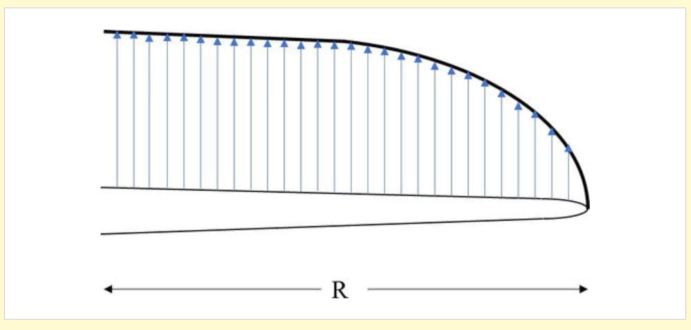

Figure 4.6 Schematic for a blade aerodynamic load.

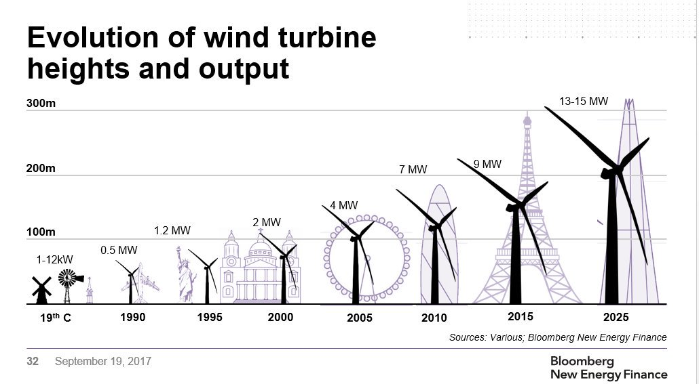

Figure 4.7 Wind Turbine Evolutions

**CHAPTER -5: STRUCTURAL MECHANICS**

#### Structural Design of Wind Turbine Blades

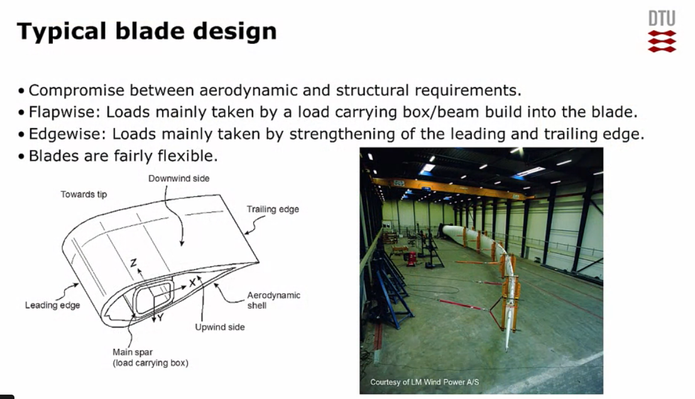Structural design is one of the most important areas of engineering. We are surrounded by structures, and it's important that they are safe, that they are reliable, and that they are efficient and do not fail, so people are hurt. Wind turbines have basically two types of loads. We have loads from the wind working on the blades in the flap-wise direction. And we have loads from gravity working on the blades in the edge wise direction. And the boundaries are where the blade is connected to the hub.

Figure 5.1

It's a compromise between the aerodynamic and the structural requirements. So, from an aerodynamic point of view we want thin air foils. But from a structural point of view, we want thick air foils that can carry the loads. So, the flap-wise loads coming from the wind is often taken by a load-carrying gurtel inside the blade while the edge-wise loading, coming from gravity, is carried by strengthening the leading edge, and the trailing edge of the blade.

In order to design, we should understand and know the mechanisms at all these length scales.

Different length scales: - Blade design requires at various length scales an understanding of material behaviour, structural behaviour and failure modes. Various length to measure blade are: -

1. Wing Scale
2. Sandwich Scale
3. Laminate Scale
4. Lamina Scale

**General Background for Wind Turbine Blades**

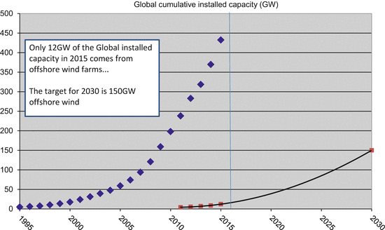Access to affordable, reliable, sustainable and modern energy is one of the 2030 targets for the United Nations (UN [2016](https://link.springer.com/chapter/10.1007/978-3-319-39095-6_2#CR7)). This requires a substantial increase in the share of renewable energy within the global energy mix, and wind is a prominent part of the solution if the world is to achieve such a target. The potential for offshore wind energy is enormous with industry projections in Europe showing an increase from 5 GW in 2012 to 150 GW in 2030 (European Wind Energy Association, Fig. [5.2](https://link.springer.com/chapter/10.1007/978-3-319-39095-6_2#Fig2) (EWEA [2016](https://link.springer.com/chapter/10.1007/978-3-319-39095-6_2#CR5))). By moving to offshore sites, the Industry can establish larger wind farms with turbines of a size that would not be easily accepted onshore where land use is at a premium. In addition to this, the quality of the wind resource is greatly improved away from the effect of land contours, forests, and so on.

**Figure5.2** Growth in Wind Energy capacity from 1995 to 2015

One of the most eye-catching developments in the wind energy industry over the last 15 years has been the increase in the size of the turbines being manufactured with new turbine designs consistently providing larger turbines with higher power ratings, as shown in Table 5.[3](https://link.springer.com/chapter/10.1007/978-3-319-39095-6_2#Tab1).

Comparison example between commercial turbines developed by Vestas in 2000 and 2015

| **Year** | **Manufacturer (rotor diameter)** | **Effect** | **Tip height** |
| --- | --- | --- | --- |
| 2000 | Vestas Wind Systems V52 | 2.5 MW | 70 m |
| 2014 | Vestas Wind Systems V164 | 8.0 MW | 222 m |

**Table 5.3**

**Innovative Blade Concept**

As the most effective way to increase the power produced per turbine is to make each turbine bigger, we now have an industry that manufactures extremely large rotor blades using low-cost fiber composite material and low-cost manufacturing methods. A consequence of the components in a wind turbine blade being so large (in some companies almost the entire structure is manufactured in one piece via resin infusion of dry laminate layers), is that there is little scope for improving the performance of a finished blade by rejecting parts that do not meet very high-quality standards. This is because the low-cost manufacturing approach demanded by the industry makes manufacturing a “perfect” blade challenging, and parts thus rejected would be too costly to simply discard.

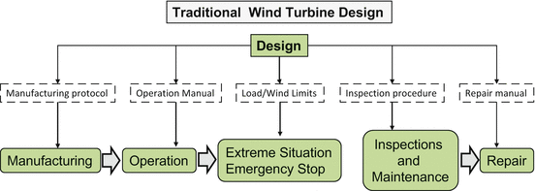Having an isolated understanding of the individual stages in the wind turbine blade operational life, such as manufacturing, operational, emergency situations, repairing, etc., is therefore not enough to achieve a smart wind turbine blade concept. Rather knowledge of how each stage interconnects with the processor and successor, and the impact of a change in any of the properties to the individual wind turbine blades operational life is required. The traditional Mono-Stage design and methodology, as shown in Fig. 5.4, is no longer applicable to match this requirement; especially as blades become larger, more complex and expensive to manufacture, more information feedback is required to maximize their lifetime and improve processes.

Figure .5.4. Traditional Wind Turbine Design

The structure since manufacture will provide feedback at each stage of the structure life time. For example, if during an extreme load a change in the material stiffness is detected, caused by delamination or a crack in the adhesive joint, the wind turbine operation limit can be decreased based on this information. This will enable the structure to operate safely until the next repair action.

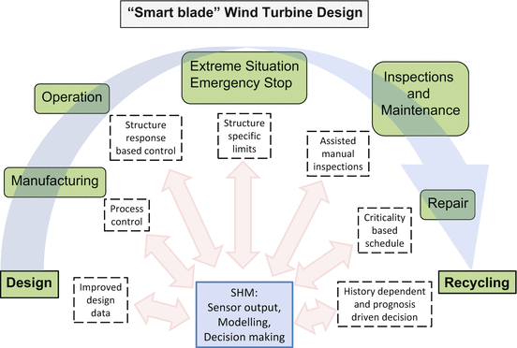

Figure 5.5 Life stages of a wind turbine blade: “smart-blade” design methodology

Structural Health Monitoring is a well-known engineering area concerned with assessing the current state of a specific asset in order to ensure proper performance. It has the perspective to function both as an automated (and remote) maintenance and inspection process, as well as a “smart” structure feedback allowing activation and response based on condition and environment.

The novel approach proposed is thus that blades are allowed to contain defects and develop stable damage under operation as under the current “passive” damage tolerant design philosophy. But the implementation of structural feedback from the embedded sensors and active response is combined with improved damage tolerant materials and design methods in order to expand the current design philosophy and include SHM and applied fracture mechanics from the initial concept. This allows a design that ensures any defects present cannot develop into unstable damage that leads to blade failure. Furthermore, a full life-time perspective is given that enables a holistic optimisation of the structural resources

**CHAPTER-6: MATERIAL SELECTION**

Wind turbines have been made from different materials such as wood, aluminium, and composites. Modern wind turbines are usually made from composites such as carbon fibers and fiber glass. The wide use of composite materials turns to its relative high stiffness to weight ratio in addition to its ability to form complex shapes. Composites are found to be efficient with the large increase in wind turbines’ size and capacities. They also can be tailored to satisfy different stiffness and weight requirements. Composite fiber can be used in different orientation to improve the blade directional stiffness in addition to bending and torsional rigidity. Fig.6.0 shows the layup process for manufacturing a 6-m-diameter wind turbine that was designed and manufactured at Cairo University laboratories.

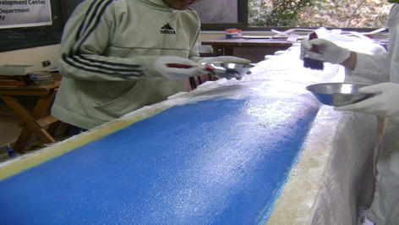

Figure 6.1 Fiberglass/epoxy blade layup

Two important things have to be considered when selecting composites:

1. Selecting the proper fiber direction for a blade structure
2. Ensuring that the final product (blade structure) has the same material properties as it was desired in the design process.

The former point can be overcome by applying a proper optimization process to select the best laminate configuration for maximizing the blade stiffness to weight ratio, while the latter issue can be resolved by testing the layup configuration after manufacturing some samples to make sure they have the same desired properties plus making experimental tests and measurements to compare between what was designed and what was manufactured.

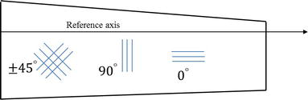There are an infinite number of orientations for composite structures. A composite layer can be oriented in any direction. However, it is important when selecting a blade laminate configuration to consider 0, 90, and ±45° angles for the blade skin. These directions are the most important fiber directions to increase the longitudinal, directional, torsional, and bending stiffnesses of a blade (Fig. 6.1).

Figure 6.1

Blade skin laminate configuration

**Blade construction and finite element analysis**

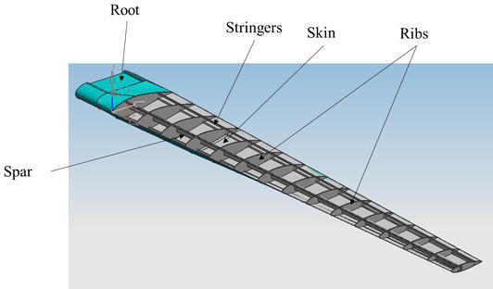The objective of wind turbine structure is to transfer and stand for wind turbine loads. Thus, it should be stiff enough to satisfy this objective. The structure weight is also important to be minimum as possible. A typical wind turbine structure consists of the skins, ribs, spar, and root or hub that connects between the blade and the wind turbine tower, as shown

Figure 6.2A 6-m-diameter typical blade structure

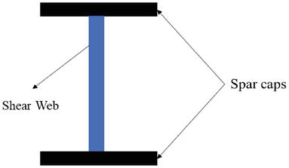The ribs represent the aerodynamic profile shape for a blade. They distribute the aerodynamic loads and transform them to the main spar, in addition to maintaining the skin profile shape. The skins protect and cover the blade structure elements. Stringers stiffen the skins and connect between the structure of the skins and ribs. A spar represents the main structure element which carries the blade’s main loads and transforms them to its root which in turn connects between the blade and the hub. A spar is usually consisting of upper and lower flanges (caps) in addition to a shear web (Fig. 6.3). The shear web performs high resistance to shear force in which the bending moment over the blade is transformed into in-plane shear forces that are carried by the shear web.

Figure 6.3 A typical blade spar section (I—section)

The geometric model available in Fig. 6.2 represents an equivalent model to the real wind turbine. This model usually is not suitable for finite element (FE) analysis. However, in finite element analysis, we use an equivalent model with some approximations that do not affect the accuracy of the analysis, but these approximations increase the speed and efficiency of the FE process. A geometric model that is physically a 3D model can be approximated into 2D or even 1D simple models. The blade skin and ribs, for instance, have a thickness dimension that is relatively smaller than the other blade dimensions; for this reason, the skin and ribs can be approximated into 2D plates in finite element analysis. Geometrically, the blade skin and ribs are modeled as surfaces. Another example is the blade stringers. They have cross-section dimensions that are relatively smaller than the length dimension. Thus, stringers are usually modeled as 1D beams in the finite element analysis. These beams are geometrically represented by lines. These modeling concepts save significant time and effort in structural analysis and design process. An example of a surface approximation for a 6-m-diameter blade ribs and lower skin is shown in Fig. 6.4.

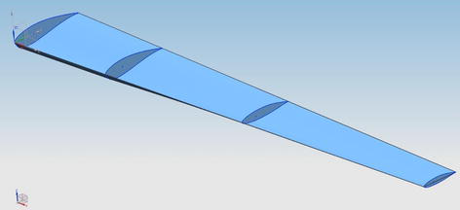

Figure 6.4Surface approximation for a blade rib and lower skin

In Fig. 6.4 the blade ribs and skin are represented by surfaces with zero thickness in which we assume there is no change either in stress or strain through their thickness. This approximation is valid as long as the thicknesses of the ribs and skin are relatively smaller than the other surface dimensions. Based on this approximation, a blade is meshed as a 3D model, but it is modeled numerically in FE using quadrilateral element. It is found that higher-order elements such as nine-node element can obtain results more accurate than linear quadrilateral elements in elastic and aeroelastic analyses. So, the element selection is also important. After approximating the blade geometry, selecting the proper element, and defining the finite element model, it is important to perform a convergence test to select the best element size and density for the blade model. Fig. 6.5 shows how the approximation from the 3D structure model to the 2D reference element is performed and the different reference coordinates that are used.

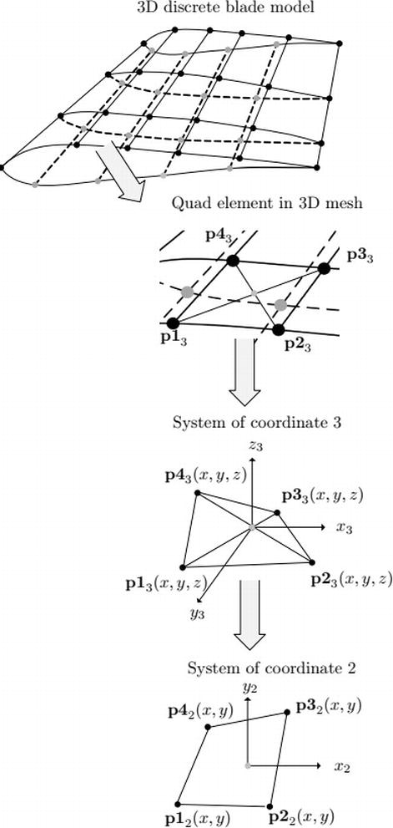

Figure 6.5 From a 3D blade finite element mesh to a 2D quadrilateral element

Fig. 6.6 shows the geometric model for 10 MW wind turbine blade. The blade has two spars, front and rear spars, in addition to 38 ribs.



Figure 6.6A 140-m-diameter wind turbine blade geometric model

**CHAPTER -7: ELECTRIC SYSTEM**

In this lesson, we will talk about good connection of wind turbines and wind power plants to the power system. There are 4 main different types of wind turbines.

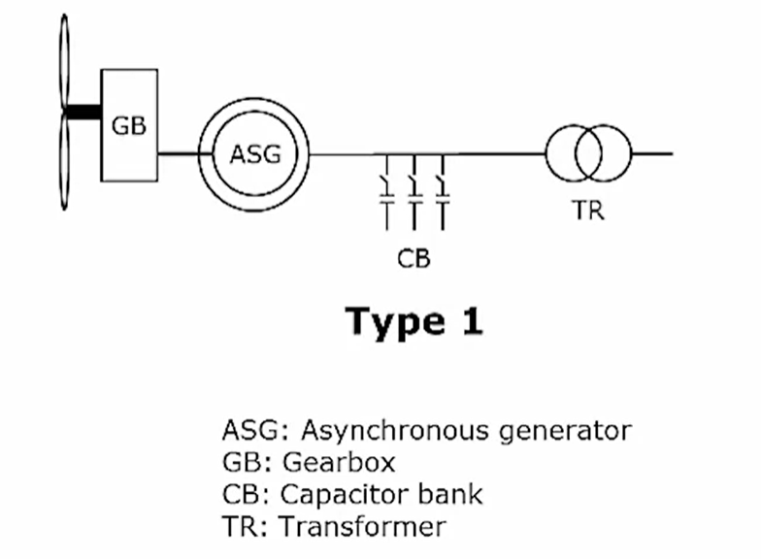Type 1: - It is based on an asynchronous generator which connects the wind turbine to the grid. The advantage of this concept is that it is very simple and very robust. The asynchronous generator rotates with a rotor speed which is determined by the frequency in grid and it does not need to be controlled. This concept also includes a gear box because the rotational speed of the asynchronous generator is much faster than what we want to have in the rotor of the wind turbine. And we also are using a capacitor bank, and the reason for this is that the asynchronous generator is consuming reactive power. And if we are not compensating for this consumption of reactive power, then we may experience problems keeping the voltage at the terminals of the wind turbine. Finally, we have in most modern wind turbines, there is a built-in transformer. This is transforming the voltage from the low voltage level to a medium voltage level in the grid where we connect the wind turbines.

Figure 7.1

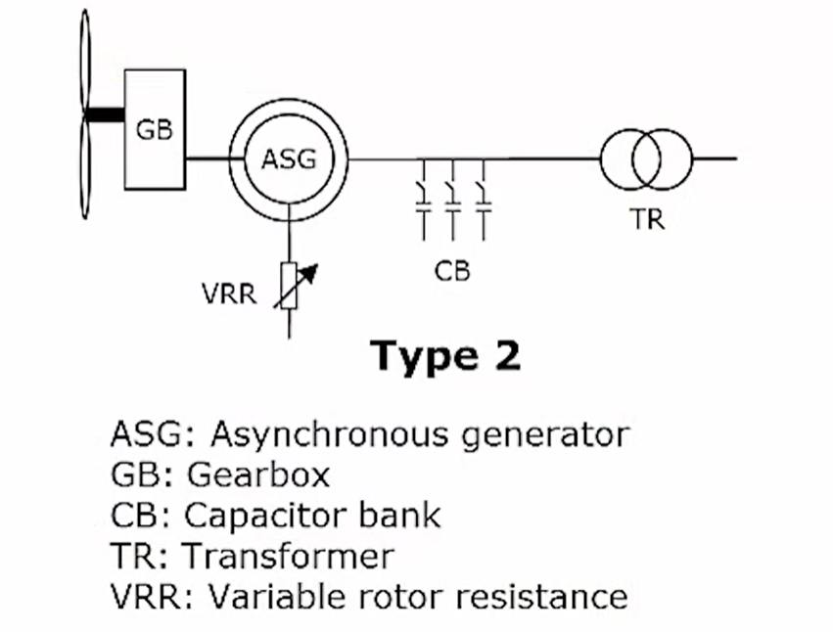Type 2: - It is a simple extension of the Type 1 wind turbine, but this makes it possible to control the rotor speed of the Type 2 wind turbine.The idea is to use a variable rotor resistance, which is seen here, and by changing the resistance.In the rotor, we can change the rotational speed of the wind turbine. This offers the opportunity to vary the speed typically with 10%, but there is also some heat loss in the variable rotor resistance which is not advantageous.

Figure 7.2

Type 3: - It utilizes the energy and is also much more controllable than the Type 2. This is connecting instead of variable resistance to the rotor we are connecting the rotor through back-to-back converter, and by this connection we can be able to utilize the energy which we were burning. In this resistor, and we can also control the speed in a much with range, the rotor speed of the generator and on top of that, we can also use this converter to control active and reactive power flow out of the wind turbine, and that is why we don't see the capacitor bank here anymore, because we don't need it because we can control the reactive power coming out of this state by controlling this back-to-back converter.

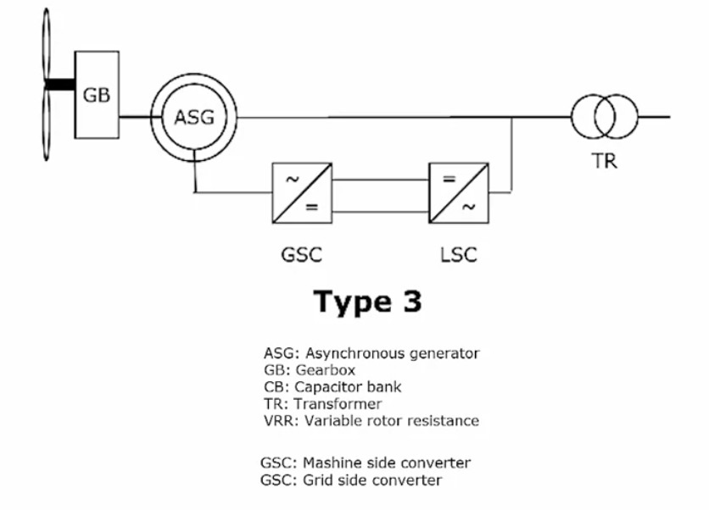Figure 7.3

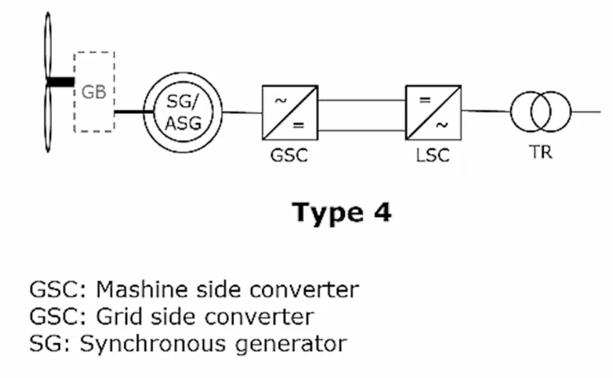Type 4: - Finally, we have the Type 4, where we have a full converter here, which is transmitting all the power. Stepping back to the Type 3, It's only about 30%, maxed 30% of the power that is passing through the converters. So, the advantage is that the converter is much smaller here. Whereas, the main power is flowing this way through this data. But in the Type 4 case, all the power is going through the converter meaning that the converter must be larger. On the other hand, we have good isolation from the grid which is, can be an advantage in the case that we have disturbances from the grid side and the cost of this is added cost for our power electronics.

Figure 7.4

**Wind Energy Power Plant**

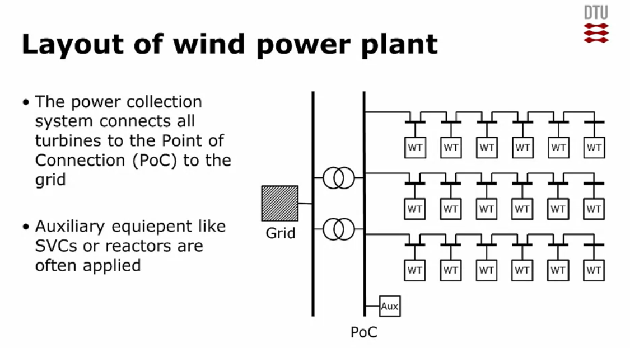There is a power collection system in the wind power plants which is collecting the power from all the wind turbines. And it is connecting them to the point of connection to the grid which is typically in the transformer station. And typically, at the lower voltage side of the transformer station, the point of connection can also, depending on which country we are in, it can also be in the high voltage side of the grid. Sometimes, it is necessary not only to have wind turbines but also to have some auxiliary equipment like reactors or SVCs which are serving to compensate for a reactive power. The wind turbines are capable of controlling reactive power. But maybe their capacity is not sufficient to what is required from the grid, and that is why in many cases we also use auxiliary equipment.

Figure 7.5. Layout of wind power plant

**CONCLUSION AND FUTURE PERSPECTIVE**

Wind energy: a sustainable solution. It is evident that the use of wind energy as a permanent solution to the current global energy concerns could be sustainable. Even so, conditions to sustainability have been evaluated. As a result, even if the resource in its current state of technology is valuable enough to be able to support various developments in the business, achievements of vast technological opportunities could end up making the resource unlimited. At the monetary level, wind energy has proven to be not only environmentally but also socially profitable to financially reinforce wind industry while ceasing to cost competitive as discussed in chapter 3 the cost for setup is high but it is definitely worth it. The time also involved in setting up a wind energy farm is also about 30-35 years. The power consumption is also given by F.V (both vector quantities).

Wind energy supports a strong domestic supply chain. Wind has the potential to support over 600,000 jobs in manufacturing, installation, maintenance, and supporting services by 2050.

Wind energy is affordable. As wind generation agreements typically provide 20-year fixed pricing, the electric utility sector is anticipated to be less sensitive to volatility in natural gas and coal fuel prices with more wind. By reducing national vulnerability to price spikes and supply disruptions with long-term pricing, wind is anticipated to save consumers $280 billion by 2050.

Wind energy reduces air pollution emissions. Operating wind energy capacity avoided the emission of over 250,000 metric tons of air pollutants, which include sulfur dioxide, nitric oxide, nitrogen dioxide, and particulate matter, in 2013. By 2050, wind energy could avoid the emission of 12.3 gigatonnes of greenhouse gases.

Wind energy preserves water resources. By 2050, wind energy can save 260 billion gallons of water—the equivalent to roughly 400,000 Olympic-size swimming pools—that would have been used by the electric power sector.

Wind energy deployment increases community revenues. Local communities will be able to collect additional tax revenue from land lease payments and property taxes, reaching $3.2 billion annually by 2050.

We also covered about the materials used in the wind blades which are the fibres and aluminium. The electrical power systems also need to be really good.

Various governments are of the view that the wind industry is prepared to take up the opened business with a green certificate market taking up all the favour. Nonetheless, in regards to a small market, there should be maintenance of a fixed price system. Socially, the actuality that the wind industry is participating to local development encourages sustainability.

Wind energy is probably the solution for our energy demands. It has great potential and is easy to manage. All you have to do is build the turbine and everything else is going to be free. With only 1 turbine, you can power over 200 homes. Every wind turbine lasts for about 20-25 years. As long as the wind blows, wind turbines can harness the wind to create power. Wind power only makes up a tiny percent of electricity that is produced. Unlike coal, wind turbines don't create greenhouse gases and are completely renewable source. Many people believe that the wind energy could soon be our main source of energy. Though wind turbines can cause complaints and fatalities of wildlife, it could be the energy solution we have been looking for.

Additionally, it’s checked authentic influence on the native inhabitants could help in incapacitating the public unwillingness. It is important to push for further research concerning potential environmental research. It is, therefore, advisable to first reconsider results of studies and environmental impact evaluation when thinking of putting up a new wind farm or reconsidering an old one.

In the coming future where meeting energy requirements would not be possible then the wind energy and all other natural sustainable sources of energy will used to fulfil the requirements.

**REFERENCES**

* [www.google.co.in](http://www.google.co.in) (Accessed on 2nd Nov 2020)
* [www.wikipedia.com](http://www.wikipedia.com) (Accessed on 4th Nov 2020)
* [www.coursera.org](http://www.coursera.org) (Accessed on 10th Oct 2020)
* [www.reddit.com](http://www.reddit.com) (Accessed on 3rd Oct 2020)
* [www.ewea.org](http://www.ewea.org) (Accessed on 5th Nov 2020)
* [www.dtu.co.in](http://www.dtu.co.in) (Accessed on 3rd Nov 2020)
* [www.youtube.com](http://www.youtube.com) (Accessed on 5th Nov 2020)
* [www.elprocus.com](http://www.elprocus.com) (Accessed on 4th Nov 2020)
* [www.springer.com](http://www.springer.com) (Accessed on 4th Nov 2020)
* [www.intechopen.com](http://www.intechopen.com) (Accessed on 1st Nov 2020)